# Recap of RDF Syntax

## RDF term:

* Literals: "lexical-form"∧∧datatype or "lexical-form"@language-tag
* IRIs, possibly HTTP(S)
* Blank nodes: abstract objects, disjoint from IRIs and literals

## RDF triple (s p o):

* s, the subject, an IRI or a blank node
* p, the predicate, an IRI
* o, the object, an IRI, a literal or a blank node

RDF graph: a set of RDF triples

RDF dataset: a collection of RDF graphs, comprising:

* Exactly one default graph, with no name and possibly empty
* Zero or more named graphs

# Recap of RDF Semantics

* Semantics: a function that gives the meaning of linguistic expressions
* Possible words: the universe is composed of a plurality of distinct worlds
* Actual word: this universe is hierarchically structured by the opposition of one element, which functions as the centre of the system, this is the actual word
* Truth: a proposition is true if it is verified in the actual world of the system but not in some other possible world
* Conceptualisation: a particular system of categories accounting for a certain vision of the world
* Interpretation structure: in order to introduce the conceptualisation from a mathematical point of view we have introduced this notion. An interpretation structure I is a pair I = (∆, ρ), where:
* ∆ is a non-empty set of resources, called the domain of discourse, and
* ρ is a finite set of binary relations, ρ = {r1, . . . ,rn}, each relation ri corresponding to a category of the conceptualisation

In RDF there are two kinds of resources with IRIs:

* individuals represent single world entities
* properties represent sets of relationships, i.e., binary relations

RDF interpretation structures are a special kind of interpretation structures. An RDF interpretation structure I consists of:

1. A non-empty set IR (Interpretation Resources) of resources, called the domain or universe of I
2. A set IP (Interpretation Properties), called the set of properties of I
3. A mapping IEXT (Interpretation EXTension) that associates to each property P in IP a relation IEXT(P) over IR, i.e., a set of pairs (x, y) with x and y in IR

IRIs are a superset of URIs (Uniform Resource Identifiers), supporting Unicode characters instead of just ASCII.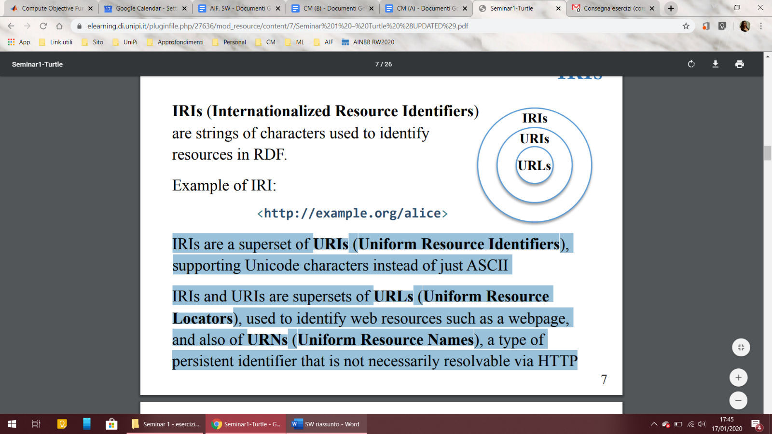

IRIs and URIs are supersets of URLs (Uniform Resource Locators), used to identify web resources such as a webpage, and also of URNs (Uniform Resource Names), a type of persistent identifier that is not necessarily resolvable via HTTP.

# Recap of Data Model

Semantic data models provide primitives to represent the world, which they view as consisting of objects and relationships between objects.

Relationships represent facts.

In the Semantic Web, objects are resources, identified by IRIs.

Semantic data modelling considers only relationships of rank 2, based on the assumptions that they are the most common, and that relationships of higher ranks can be reduced to equivalent relationships of rank 2.

Relationship types are represented by properties and relationships are represented by triples including the involved resources and the property connecting them.

World representations take the form of semantic networks.

# Recap of RDF Vocabulary

* rdf:type predicate expresses the type of the resource
* rdf:Property is the set of properties
* rdf:XMLLiteral is the datatype of XML literals
* rdf:List, rdf:first, rdf:rest, and rdf:nil can be used to write lists (RDF collections)
* Ordered, unordered, and alternate containers of values can be described using rdf:Seq, rdf:Bag, rdf:Alt, rdf:_1, rdf:_2
* Reification can be expressed with rdf:Statement, rdf:subject, rdf:predicate, and rdf:object
* Structured values are described using rdf:value

# Recap of RDFS Vocabulary

Abstraction mechanisms for organizing the knowledge in a semantic network:

1. classification
2. specialization/generalization
3. property typing

These mechanisms introduce new knowledge into the initial network, knowledge about the universals of our discourse: classes and properties Universals are part of our conceptualization, that is of the abstract, simplified view of the world that is of interest for us.

Four IRIs for specifying abstraction mechanisms in RDFS:

* rdfs:subClassOf, for stating specialization/generalization relationships between classes e.g. ex:Person rdfs:subClassOf ex:Agent .
* rdfs:subPropertyOf, for stating specialization/generalization relationships between properties e.g. ex:son rdfs:subPropertyOf ex:child .
* rdfs:domain, for stating that a class is the domain of a property e.g. ex:isBorrowedBy rdfs:domain ex:Book .
* rdfs:range, for stating that a class is the range of a property e.g. ex:isBorrowedBy rdfs:range ex:Person .
* rdfs:Container is a super-class of the RDF Container classes, i.e. rdf:Bag, rdf:Seq, rdf:Alt
* rdfs:ContainerMembershipProperty class has as instances the properties rdf:_1, rdf:_2, rdf:_3 . . . that are used to state that a resource is a member of a container
* rdfs:member is an instance of rdf:Property that is a super-property of all the container membership properties i.e., each container membership property has an rdfs:subPropertyOf relationship to the property rdfs:member
* rdfs:seeAlso is an instance of rdf:Property that is used to indicate a resource that might provide additional information about the subject resource
* rdfs:isDefinedBy is an instance of rdf:Property that is used to indicate a resource defining the subject resource.

|  |  |  |
| --- | --- | --- |
|  | Classi | Proprietà |
| **Intension** | caratteristiche catturate dalla classe (definizioni generali, indipendenti da qualsiasi situazione particolare) | insieme delle caratteristiche che ne trasmettono il significato |
| **Extension** | insieme di risorse che sono membri di una classe in una situazione particolare | insieme delle relazioni che hanno la proprietà come “tipo” in una particolare situazione |

Se due classi hanno intensioni diverse, potrebbero avere stessa estensione in alcune situazioni ma diversa in altre.

Classi con stessa estensione in ogni situazione possibile si dicono **equivalenti**, ma questo accade se e solo se hanno stessa intensione. Due classi sono la stessa se hanno la stessa estensione in ogni IS

Comprendere una affermazione = sapere in quale RDF IS essa è vera e in quali è falsa.

Comprendere una classe = sapere quali risorse sono membri di essa in ogni RDF IS.

Comprendere una proprietà = capire l’estensione di essa in ogni possibile RDF IS.

*Es. the extension of ex:Person is a subset of the extension of class ex:Agent, or, equivalently, that every instance of class ex:Person is also an instance of class ex:Agent (but the opposite is not necessarily true).*

rdfs:subClassOf denota la **relazione di sottoinsieme** tra estensioni di classe in ogni RDF IS.

La relazione di sottoinsieme è **riflessiva** e **transitiva**: se A è sottoclasse di B e B è sottoclasse di C allora A è sottoclasse di C (**RDFS-entalis** 🡪 implicazione).

Analogamente per rdfs:subPropertyOf

## La semantica di dominio e range

Per quanto riguarda l’intensione, il dominio di una proprietà comprende le risorse per cui essa ha senso.

Di conseguenza, in ogni RDF IS, se una coppia di risorse (*a b*) è nell’estensione della proprietà P, allora *a* è nell’estensione del dominio di P, mentre *b* è nell’estensione del range di P.

*ex:IsBorrowedBy rdf:domain ex:Book .*

*ex:IsBorrowedBy rdf:range ex:Person .*

*a ex:IsBorrowedBy b .*

RDFS-entail 🡪 *a rdf:type ex:Book .*

*b rdf:type ex:Person .*

Se una proprietà P ha più di un dominio (D1, D2, …, Dn), allora le risorse denotate come soggetto delle triple con predicato P sono istanze di TUTTE le classi D1, D2, …, Dn .

Analogamente per range.

*RDF Schema has severe limitations in capturing the intension of classes and properties: no negation, no disjunction, no numerical restrictions, no quantifiers… To overcome these limitations, we must look into the OWL language.*